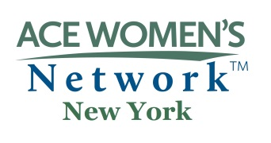
Presented by the NYS American Council on Education (ACE) Women’s Network

The ACE Catalyst Award Nomination Form

The “ACE Catalyst Award” will be awarded on an annual basis to a woman leader in higher education who:

- Exemplifies the mission of ACE Women’s Network which includes the following:
  - to develop and promote the advancement of women in high education in New York state
  - to increase the number, visibility, and influence of women in leadership roles in higher education
  - to establish linkages among and between women and trustees, legislators, policy makers, search firms, and other organizations
  - to develop an agenda of policy issues affecting women in higher education
  - to support, encourage, and strengthen the state and regional associations

- Dedicates herself to higher education by serving her students, colleagues, and institution generously;

- Demonstrates a personal commitment to professional growth and enrichment;

- Unselfishly gives her time and energy in assisting other women in their professional development as a mentor and role model; and

- Advances and promotes higher education through collaborative efforts across disciplines in academics, government and business communities.

Name of Nominee: Title:

Phone: Email:

Institution:

Address:

Name and Title of Nominator:

Institution:

Nominator’s phone & email address:

Date

Please indicate in the expandable space below why you believe your nominee should be considered to receive this award. Be specific about how she meets the award criteria by giving examples, if possible, for each. (Note that the nominees do not have to meet every single criteria.) The selection committee will contact the nominee for their CV and letter of interest.

Email the completed form, along with any supporting documents to:
secretary@nyacewomen.org

***Nominations must be received by end of business March 1***

Recipient will be given the award at the annual state conference on Friday April 3, 2020

