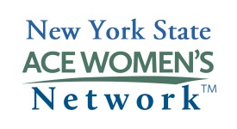

NYS American Council on Education (ACE) Women’s Network

Regional Representative Nomination Form

Criteria:

- Understands the mission of ACE/National Network of Women Leaders;
- Commits to promoting and helping to develop ACE-sponsored events/programs to women in higher education within her region
- Demonstrates a commitment to the professional growth and enrichment of women

Specific tasks include the following:

- Convene regular meetings with the Institutional Representatives of the Region;
- Convene a group of women aspiring to administrative leadership positions in conferences, workshops or other meetings as appropriate to design or implement a specific agenda in behalf of women;
- Actively identify and nominate new Institutional Representatives in the Region;
- Seek opportunities to partner, link and discuss with other associations or networks having similar goals;
- Provide the New York State Chair and Executive Board with a periodic activity report on the work and initiatives undertaken by the relevant Region.

Name of Nominee: Date:
Title:

Phone:
Institution:
Address:
Email:

ACE Region:
Name of College/University President:

Please indicate in the expandable space below why you believe you should be considered to be an ACE regional representative. Be specific about how you/she meets the criteria. Please attach a current vita.

Name of nominator (or self):

*Email completed form to:
Mary Bonderoff
Chief Diversity Officer and Title IX Coordinator
SUNY Morrisville
bonderm@morrisville.edu

